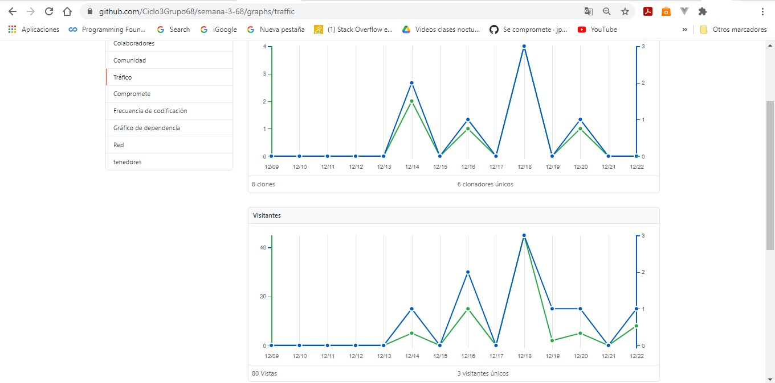

<https://github.com/Ciclo3Grupo68/semana-3-68>